**Notes COMP206 Test #1**

1. A **system** is a set of interconnected artifacts in which each artifact carries out a function, artifacts can interact with each other (send data, get data, execute a function). Rules exists that define legal interactions.
2. **System programming** involves designing and writing computer programs that allow the computer hardware to interface with the programmer and the user, leading to the effective execution of application software on the computer system.
3. **Low level languages** are difficult to write and compile, but **high level languages** are easy to write as well as compile.

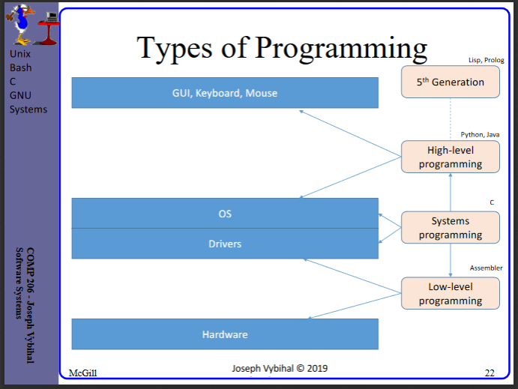

1. **Unix OS Components**: Kernel, File System, Shell, Utilities
2. **OS functions**: interact with a computer without having to know the inner working of the computer, mange the computer’s resources, provide libraries.
3. **Three basic tasks of shell**: Get user input, display OS information, store session information

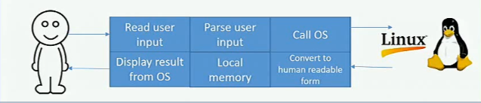

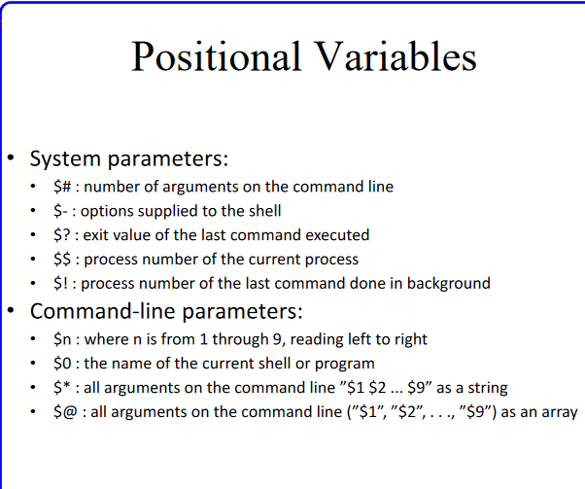

1. 